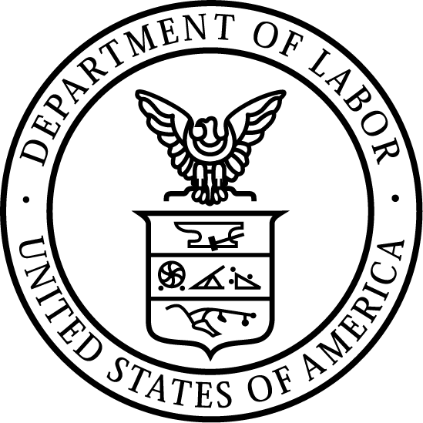
News Release
U.S. Department of Labor | February 16, 2023
US Department of Labor seeking public comments on modernizing program that recognizes employers committed to best safety, health practices
OSHA’s successful Voluntary Protection Program helps provide safe workplaces

WASHINGTON – The U.S. Department of Labor announced that its Occupational Safety and Health Administration is inviting the public and workplace safety stakeholders to share their comments on how the agency can best honor companies who make exceptional commitments to workplace safety and health, and encourage others to follow.

Established in 1982, OSHA’s Voluntary Protection Program recognizes workplaces that demonstrate best practices in safety and health management and serve as industry models. In the last 40 years, the program has attracted a wide variety of organizations in many industries. VPP’s success has stretched OSHA resources and made it more difficult to ensure the quality of program applicants’ safety and health management systems.

By opening the program to public comments, OSHA seek input from all perspectives to assist the agency as it modernizes and enhances the VPP, and continues to promote the use of workplace safety and health management systems. The Voluntary Protection Program’s modernization project is seeking stakeholder input on issues such as:
- Aligning the program more closely with recent occupational safety and health management practices and system standards.
- How the program can contribute to expanding the use and effectiveness of safety and health management systems.
- Whether and how resources and tools such as “special government employees,” consensus standards, third-party auditors and other methods could serve to expand the program’s capacity without compromising effectiveness and oversight.
- Whether particular categories of hazards need special attention in the VPP certification process.

OSHA is asking a series of questions in 10 sections to elicit useful responses to support the project’s aims. Interested members of the public should submit comments and attachments, identified by Docket No. OSHA-2022-0012, using the Federal e-Rulemaking Portal. The deadline for comments is April 14, 2023.

Learn more about OSHA and the Voluntary Protection Programs.
# # #
Media Contacts:

Amanda McClure, 202-693-4675, mcclure.amanda.c@dol.gov
Victoria Godinez, 202-693-4667, godinez.victoria.c@dol.gov
Release Number: 23-226-NAT

